

1. **S HARSHITH (29)**
2. **SADAT ZUBIN AFTAB SHAH (30)**
3. **SANJANA S CHODANKAR (31)**
4. **SHAKSHI CHOURASE (32)**
5. **SHOBHA RAMCHANDRA MASTI (33)**



**Coronavirus: Impact on Education and Revival**

**Group Report**

**Certificate**

**This is to certify that the work on the project entitled “Impact of Coronavirus on Education and it’s Revival” has been carried out by the following students who are bonafide students of National Institute of Technology, Goa.**

**Group D**

1. **S HARSHITH (29)**
2. **SADAT ZUBIN AFTAB SHAH (30)**
3. **SANJANA S CHODANKAR (31)**
4. **SHAKSHI CHOURASE (32)**
5. **SHOBHA RAMCHANDRA MASTI (33)**

**Project guide: Prof Gajanan T Hivale**

**Acknowledgement**

**We would like to express our special thanks and gratitude to our respected professor, Dr. Gajanan T Hivale sir, who gave us this wonderful project of writing a report on “Impact of Covid–19 on education and it’s Revival”. This project report made us to think much deeper into the current scenario and made us to analyze the present situation of this pandemic and its impact.**

**We once again express our gratitude to our professor**

**Dr.Gajanan T Hivale for giving us this wonderful opportunity.**

**Abstract**

**The impact of pandemic COVID-19 is observed in every sector around the world. The education sectors of India as well as world are badly affected by this . It has enforced the worldwide lockdown creating very bad effect on student’s life. Around 32 crore learners stopped to move schools/colleges all educational activities halted in India. The outbreak of COVID-19 has advised us that change is inevitable. It has worked as a catalyst for the educational institutions to grow and opt for platforms and techniques which been not used before. The education sector fighting and facing many challenges.**

**This report highlights some measures taken by govt. in improving the education sector. We would be discussing pros and cons in education sectors happened at the time of COVID-19. Some suggestions were also discussed in this report to be carry out educational activities in this pandemic situation.**

**Outline of the Report**

* **Introduction**
* **Statement of the problem**
* **Significance of the problem**
* **Detail study of the problem**
* **Analysis of the data**
* **Summary**
* **Conclusion**
* **Bibliography**

**Since the wake of Coronavirus in India in early March, all the sectors of economy were fractured, among them education was one of the biggest victims of coronavirus and also one of the most debated and scrutinised sectors throughout the pandemic. Lots of difficulties and challenges were faced by the students, teachers and parents in continuation of the academic progress of the students. Lots of transition were seen in the teaching learning standards all over the pandemic.**

**Introduction**

**In this report we’ll review the impact of Coronavirus on Education and draw out important points to consider while reviving the Education system back on track.**

* **To study the consequences of Coronavirus pandemic on Education.**
* **After almost one year of Coronavirus pandemic,**

**Which is better Online or Offline classes?**

* **What protocols and key points we need to keep in mind before restarting offline classes.**

**Statement of the problem**

* **Impact of Coronavirus on student’s education:**
* **School Closure**

**Govt. announced closure of all educational institutes all over India to limit the spread of Coronavirus and to gather the necessary forces to fight against the invisible virus.**

* **Problem of Distance Learning**

**Since many students could not continue with their offline mode of learning because of lockdown, many student’s academic progress was halted down.**

**Significance of the problem**

* **Access of internet and other services in remote areas**

**Many rural areas in India are not equipped with proper internet availability and thus it was a challenge for the students of those areas to continue with their education.**

* **Extra burden on Parents and Teachers**

**Parents who were already in financial debts could not afford the cost of online classes of their children. Also, teachers from many private institutes were not paid salary and there were regular protests from parents of the students opposing fee hike.**

* **Increased anxiety within students due to uncertain exams**

**Students were tensed about their preparation and were in deep anxiety resulting due to uncertain exams. Few students could not bear their stress levels and even committed suicide.**

* **Impact of Coronavirus on student’s education:**
* **Loss of hopes for pursuance of International Education**

**Since Coronavirus is widespread in western countries with dangerous mutations, there is loss of hopes in minds of aspirants who wanted to procure higher studies from International institutes.**

* **Impact on physical health on students**

**Since students have to sit for almost half a day in order to pursue their online mode of learning, it has a detrimental impact on the physical health of the students. Due to prolonged screen time problems of eye strain and redness have become frequent. Also, due to prolong use of earphones can result in noise induced deafness.**

**Significance of the problem**

* **Lack of mutual interaction between students**

**Due to online mode of learning, students cannot have any mutual interaction with their peers as a result, there is a deteriorating impact on the overall development of a student.**

* + **Review of Problem Statement: -**

**“*After almost one year of corona virus pandemic which is better online or offline?”***

* **Choosing between offline and online education could be a daunting task but with the right guidance, you will be able to make the right decision for you. As technology has developed, so too has the way we learn new skills. Thanks to the internet, those interested in boosting their knowledge and skills now have a wide range of options open to them.**

**Detail Study of the problem**

* **Attending online classes every day has become the ‘new normal’ for students during the lockdown in India. As schools were shut because of the lockdown to contain the spread of coronavirus, the online class have taken center stage in students’ life now.  
  Despite the lockdown, many schools have taken timely steps to continue the flow of education by holding online classes for students. Interestingly, online classes have helped students during lockdown more than ever before.**
* **Although online learning has become the preferred method for the majority of students, it’s important not to dismiss the benefits of offline learning too.** 
  + **Weighing the Pros and Cons of Online Education**
* **Although online school might provide some flexibility being unrestricted in regard to location and times but with offline learning, it’s easier to ensure students are paying attention to the training.**
* **Some students also find it easier to retain the knowledge and skills they’ve learnt through offline learning than they do with online learning**

**Detail Study of the problem**

* **Online classes help you to develop self-discipline and makes you join study groups from different places to understand perspectives whereas classroom studying provides an opportunity for students to engage in live discussions where they can better utilize their critical thinking skills to voice opinions or involve in an argument.**
* **Infrastructural issues such as internet connectivity and lack of instruments are prevailing. Students in cities with a good internet connection have been able to join in for the classes, but those in villages or are in small towns struggle with the internet speed and are mostly unable to attend the classes.**
  + **Weighing the Pros and Cons of Online Education**
* **If the colleges and schools plan to go for online exams, half the students who are in towns and villages will fail for sure because they will not be able to connect whereas this is not a problem for classroom learning.**
* **Even though online school is the reality of the ‘new normal’ situation and cannot be ignored. However, it is equally important to understand that the online education mode cannot be the alternative of face-to-face teaching, and it can always be supplementary.**

**Detail Study of the problem**

* **We have to look forward in transitioning from the online mode to offline mode sooner or later.**
* **Is it entirely safe to conduct Online classes?*”***
* **We address this entire question by further emphasis and highlighting the key points.**
* **Considering the wide range of facts collected from various sources it is recommended that reopening of the offline classes would be beneficial to the majority.**
* **Yet the decision cannot be rested on this, we still have to take into account the risks that we may have to encounter during the offline classes.**

**Detail Study of the problem**

* **For this let us recollect the dangers faced in IIT Madras due to the opening of the institute which was a frightening event. The IIT-Madras cluster of COVID-19 infections that was detected in early December created a flutter in Tamil Nadu. Places where people converge, particularly dining places, closed spaces and crowded places, and contacts of positive persons were some of the few reasons due to the outburst of the cases. In particular, frequent crowding at the mess, shared toilets, difficulties in monitoring staff and scholars coming from outside, and possible delay in testing contacts of affected persons are other reasons that may have exacerbated the situation.**
* **Is it entirely safe to conduct Online classes?*”***
* **Precautions need to be in place — wearing masks at all times, maintaining physical distance, and stringent monitoring of eating areas.**
* **“We need to maintain a considerable distance of a minimum of two meters between persons while not wearing masks. When everyone wears a mask, safe physical distance can be just two feet between them. These norms should apply for those serving food too. With these rules in place, campuses can be infection-free. Otherwise, they could turn notorious for large outbreaks.**

**What happened at IIT-Madras could happen with any academic institution as long as the pandemic continues and if discipline in following precautions is not strictly maintained**

**Detail Study of the problem**

* **What should be considered when deciding whether to**

**re-open schools or keep them open?**

* **Several elements should be assessed in deciding to re-open schools or keep them open:**
* **The epidemiology of COVID-19 at the local level: This may vary from one place to another within a country.**
* **Benefits and risks: what are the likely benefits and risks to children and staff of open schools? Including consideration of:**
  + **Transmission intensity in the area where the school operates: No cases, sporadic transmission; clusters transmission or community transmission**
  + **Overall impact of school closures on education, general health and wellbeing; and on vulnerable and marginalized populations (e.g. girls, displaced or disabled)**

**Detail Study of the problem**

* + **Effectiveness of remote learning strategies.**
* **Detection and response: Are the local health authorities able to act quickly?**
* **The capacity of schools/educational institutions to operate safely.**
* **The range of other public health measures being implemented outside school**
* **WHO recommends the following:**
* **Community-level measures: Carry out early detection, testing, contact tracing and quarantine of contacts;**
* **investigate clusters; ensure physical distancing, hand and hygiene practices and age-appropriate mask use;**
* **shield vulnerable groups**
* **Behavioral aspects: Consider the age and capacity of students to understand and respect measures put in place. Younger children may find it more difficult to adhere to physical distancing or the appropriate use of masks.**

**Detail Study of the problem**

* **Hygiene and daily practices at the school and classroom level: Physical distancing of at least 1 meter between individuals including spacing of desks, frequent hand and respiratory hygiene, age-appropriate mask use, ventilation and environmental cleaning measures should be in place to limit exposure. Schools should educate staff and students on COVID-19 prevention measures, develop a schedule for daily cleaning and disinfection of the school environment, facilities and frequently touches surfaces, and ensure availability of hand hygiene facilities and national/local guidance on the use of masks.**
* **Screening and care of sick students, teachers and other school staff: Schools should enforce the policy of “staying home if unwell”, waive the requirement for a doctor’s note.**
* **WHO recommends the following:**
* **Protection of individuals at high-risk: Schools should identify students and teachers at high-risk with pre-existing medical conditions to come up with strategies to keep them safe; maintain physical distancing and se of medical masks as well as frequent hand hygiene and respiratory etiquette.**
* **Another factor that plays a major role and is absolutely vital to the reopening of the schools would be to take into account the active cases of corona virus in the locality where the schools are situated. If the condition is highly unfavorable it is indeed a better option to stick to the online classes.**

**Detail Study of the problem**

* **Availability of vaccine is another key determining factor, which would enable the masses to enter their respective schools and colleges without a perpetual trace of fear or anxiety.**
* **What should be monitored after re-opening of school?**

**The following should be monitored:**

* **Effectiveness of symptoms-reporting, monitoring, rapid testing and tracing of suspected cases**
* **The effects of policies and measures on educational objectives and learning outcomes**
* **The effects of policies and measures on health and well-being of children, siblings, staff, parents and other family members**
* **The trend in school dropouts after lifting the restrictions**
* **The number of cases in children and staff in the school, and frequency of school-based outbreaks in the local administrative area and the country.**

**Detail Study of the problem**

* **Assessment of impact of remote teaching on learning outcomes.**

**Based on what is learned from this monitoring, further modifications should be made to continue to provide children and staff with the safest environment possible.**

**If all these factors do not signify a major threat to the whole it is recommended that the offline classes be resumed for the smooth functioning of the education system.**

* **Susceptibility to COVID-19 rises with age**
* **In transmission modals fitted to epidemic data from China, Italy, Japan, Singapore, Canada & South Korea.**
* **The percentage of persons infected among the exposed (susceptibility) and the percentage with symptoms among those infected (clinical fraction) both generally increase with age.**

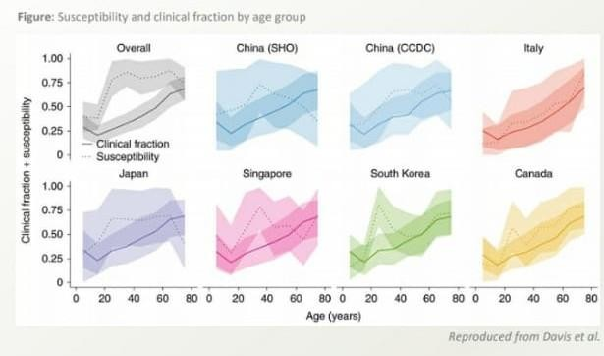

**Analysis of Data**

* **Fewer children under 10 have antibodies compared to adolescents and adults**
* **7.9% of the population of Geneva had developed antibodies by May 9th.**
* **Antibody prevalence was much lower in children aged 5-9 years and in adults 65 years or older than those aged 10-64 years.**
* **This suggests fewer children under 10 had been infected.**
* **Adolescents has a similar prevalence as young adults.**
* **Limitations: -**

1. **Sample only included children 5 years or older.**
2. **Younger children had a higher proportion of indeterminate test results.**
3. **The performance of the test is uncertain in children. The commercially available ELISA was only validated for adults.**

**Analysis of Data**

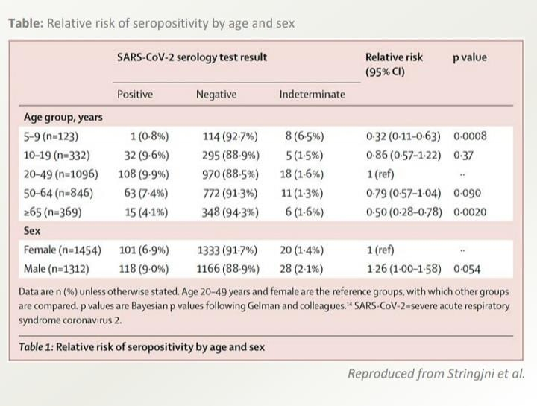

* **Children under 10 are less likely to pass on the virus to other than adolescents and adults**

**Analysis of Data**

**A large contact-tracing study in the Republic of South Korea**

* **Among 59,073 contacts of 5,706 covid-19 patients, 12% of household contacts tested positive for covid-19.**
* **Only 5% of contacts of children aged 0-9 years become infected, the lowest for all age groups.**
* **This suggests young children are less contagious than older children and adults.**
* **Limitation: -**

1. **Direction of transmission was not rigorously documented, and this could account for significant bias.**
2. **Number of cases and contacts were very small in the younger age groups.**

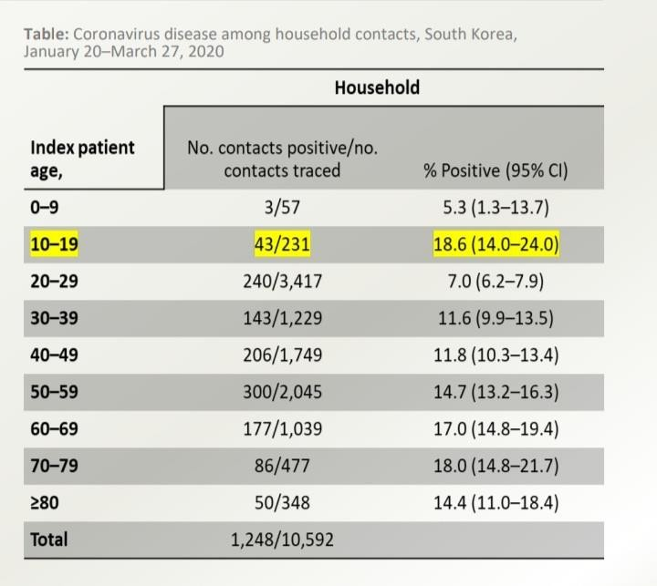

* **Limited SARS-CoV-2 infection in schools with public health measures**
* **Public Health England (PHE) initiated enhanced surveillance following the reopening of schools during a summer mini- turn on 01 June 2020.**
* **Re-opening of schools was associated with few covid-19 outbreaks when public health measures were in place.**
* **67 single confirmed cases, 4 co-primary cases and 30 covid-19 outbreaks during June 2020.**
* **Strong correlation between number of outbreaks and regional covid-19 incidence.**
* **Staff members had a higher risk of SARS-CoV-2 infection than students; most cases linked to outbreaks were in staff.**

**Analysis of Data**

* **Additional interventions should focus on reducing transmission in and among staff members.**

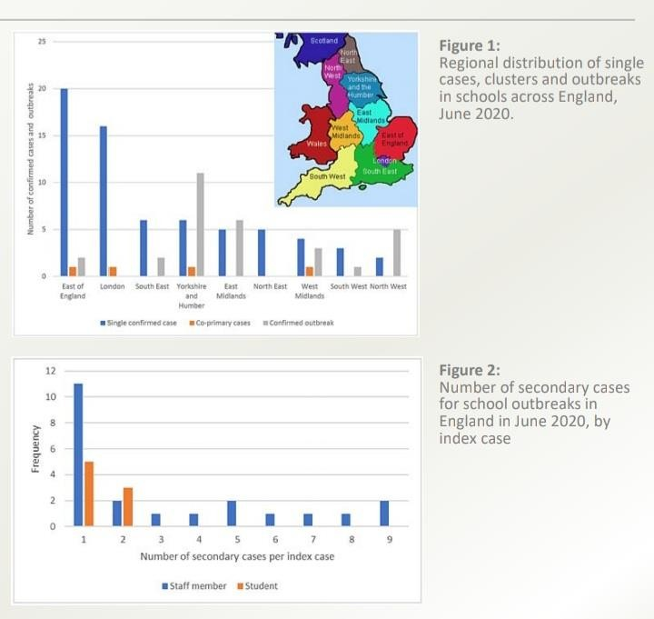

* **Large covid-19 outbreak in a high school with insufficient public health measures**
* **On 13 March 2020, Israel closed all schools, then fully reopened on 17th May.**
* **Measures included daily health reports, hygiene, facemasks, social distancing and minimal interaction between classes.**
* **On 19-21 May during an extreme heatwave, the Ministry of Health exempted pupils from wearing masks. Windows were closed and air-conditioning functioned continuously.**
* **Classes were reported crowded, ten days later a major covid-19 outbreak occurred in a high school.**

**Analysis of Data**

1. **178 confirmed cases: 153 students (Attack rate: 13%) and 25 staff (Attack rate:17%).**
2. **43% of student cases and 76% of staff cases reported symptoms. It was concluded that public health measures were not adequate and contributed to the outbreak.**

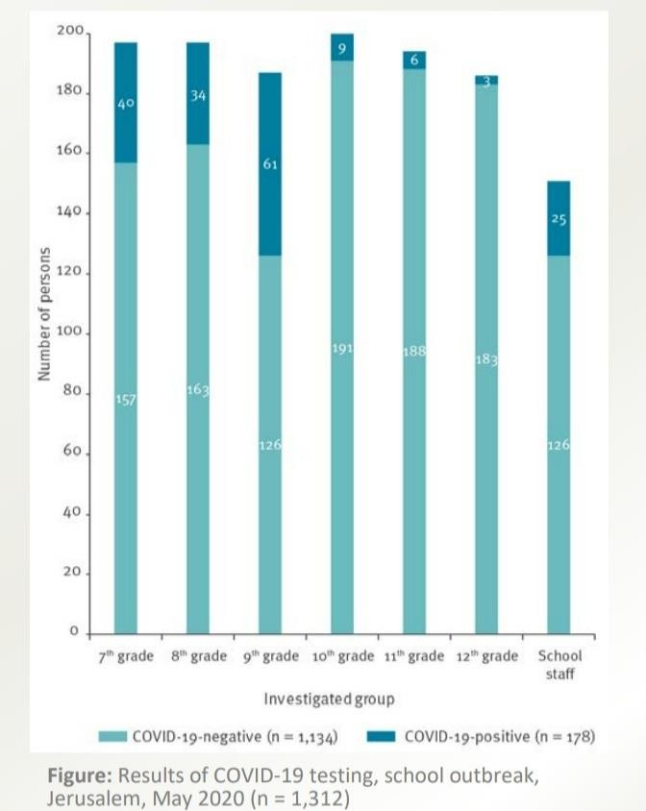

* **The covid-19 pandemic has affected educational system worldwide leading to the near total closure of schools, universities and colleges.**
* **A new way of digital learning was found to teach children.**
* **It was a very big challenge for teachers, parents and students.**
* **Many teachers were never exposed to online teaching.**
* **For online classes phone or laptop and internet are very essential but parents who were financially weak could not afford it.**
* **Examination cycle was disturbed, which increased anxiety within the students.**
* **Online classes have helped us to continue with the teaching and learning process, and it has now become a new normal in the student’s life during the pandemic.**

**Summary**

* **Advantages of online classes are that we can attend classes from anywhere. Also, it helps us to become disciplined.**
* **Online classes also have some disadvantages. As we cannot interact lively, and we also need the electronic devices, also students have to sit in front of the screen for long time.**
* **Although online classes have become a new normal it can only be supplementary of offline classes.**
* **If offline classes are to be started then there are some key points to be kept in mind.**
* **We have to see whether it is entirely safe to start with offline classes as the effect of the virus is still not finished.**

**Keeping in mind the current scenario of the hazards of coronavirus and challenges in the efficiency of practical implementation of precautionary measures we can conclude that it is entirely not safe to conduct offline classes.**

**Conclusion**

**The best option would be to explore the digital means of teaching in this present scenario.**

* [**https://scroll.in/article/960930/indian-education-cant-go-only-8-of-homes-with-school-children-have-computer-with-not-link**](https://scroll.in/article/960930/indian-education-cant-go-only-8-of-homes-with-school-children-have-computer-with-not-link)
* [**https://www.thehindu.com/news/national/andra-pradesh-/online-classes-students-complain-of-eye-and-ear-problems/article 31863501.ece**](https://www.thehindu.com/news/national/andra-pradesh-/online-classes-students-complain-of-eye-and-ear-problems/article%2031863501.ece)
* [**https://thewire.in/education/neet-covid-19-medical-exams-masks-tamil-nadu**](https://thewire.in/education/neet-covid-19-medical-exams-masks-tamil-nadu)**.**
* [**https://www.unicef.org/press-releases/two-thirds-worlds-school-age-children-have-no-internet-acces-home-now-unicef-itu**](https://www.unicef.org/press-releases/two-thirds-worlds-school-age-children-have-no-internet-acces-home-now-unicef-itu)**.**
* **https://en.wikipedia.org/wiki/COVID-19_pandemic_in_India**

**Bibliography**

**Thank**

**you**